***Maths Homework :03***

Year: 8

Student Name: ________________ Date: 15/10/2020

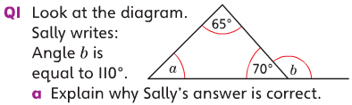



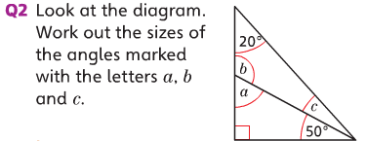

Q3. Use a compass and a ruler to construct a triangle ABC where AB = 6cm  
 AC= 4cm and BC = 6cm.

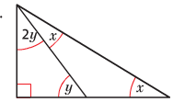

Q4. Look at the triangle and work out the value of y